34.9: a)
b) For 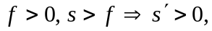so the image is always on the outgoing side and is real. The magnification is 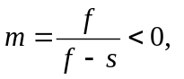since 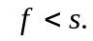
c) For 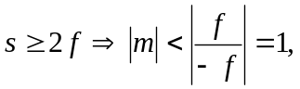which means the image is always smaller and inverted since the magnification is negative.
For 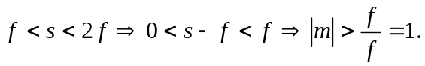
d) Concave mirror: 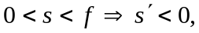and we have a virtual image to the right of the mirror. 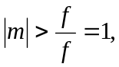so the image is upright and larger than the object.

